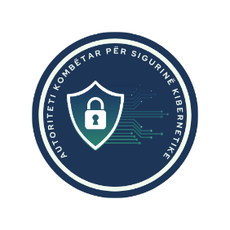
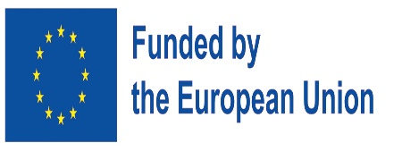


WORKSHOP ON CYBERSECURITY IN THE 5G TOOLBOX

Venue: TBD
Date: 12 or 13 March TBC
Target Audience:
The workshop is designed for professionals involved in 5G development, regulation, and security. Policymakers will gain legal insights, telecom operators will explore risk mitigation, and cybersecurity experts will discuss threat detection. Legal specialists will enhance compliance knowledge, while industry stakeholders can stay updated on securing 5G infrastructure.
Approx no of participants: 30

DRAFT AGENDA

09:00 – 09:30 | Registration & Welcome Coffee
09:30 – 09:45 | Opening Remarks
- Mr. Igli Tafa, General Director, AKSK TBC
- AKEP Representative TBC
- Ms. Irena Malolli, Director, Directorate of Policies and Strategies for Development of Pot and Telecomunication, Ministry of Instrastructure and Energy TBC
- Mr. Milan Sekuloski, Senior Cybersecurity Expert, e-Governance Academy TBC
09:45 – 10:30 | Overview of the EU 5G Cybersecurity Toolbox
- Expert TBD
10:30 – 11:15 | Legal and Regulatory Frameworks for 5G Security in Albania
- Ms. Irena Malolli, Director, Directorate of Policies and Strategies for Development of Pot and Telecomunication, Ministry of Instrastructure and Energy
11:15 – 11:30 | Coffee Break
11:30 – 12:15 | Implementation Measures & Best Practices
- Expert TBD
12:15 – 13:00 | Challenges & Opportunities in 5G Security Governance
- Expert TBD
13:00 – 14:00 | Networking Lunch
14:00 – 15:30 | 5G Network Architecture, Security Measures & Incident Response in 5G Networks
- Mr. Beldar Kazia, Technical Director at Electronic and Postal Communications Authority – AKEP- TBC
15:30 – 15:45 | Coffee Break
15:45 – 16:30 | Hands-On Technical Exercise / Case Study
- Expert TBD
16:30 – 17:00 | Closing Remarks & Next Steps

