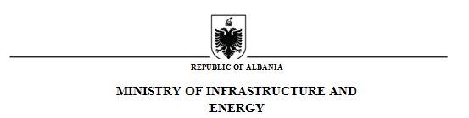

Protocol No._______ Tirana on, ___ .___.2021

NOTICE OF CONTRACT

1. Name and address of the Contracting Authority

Name Ministry of Infrastructure and Energy
Address "Abdi Toptani" St., No. 1, Tirana, Albania
Tel/Fax +355422222245
E-mail valbona.pepa@infrastruktura.gov.al
Website www.infrastruktura.gov.al

2. Type of procurement procedure: “Open Procedure –public procurement through electronic means”
3. Object of the framework contract/agreement: “The Construction of Llogara Tunnel” (in the road section Orikum-Himare part of the Sh8 Motorway (Vlora – Saranda)
4. Procedure/lot reference number: REF-98814-06-22-2021

5. Limit fund: is 18 967 810 952.08 ALL (eighteen billion nine hundred sixty-seven million eight hundred ten thousand nine hundred fifty-two point zero eight) ALL excluding VAT
6. Contract duration or term for execution: 37 months from the date of signing of the contract
7. Deadline for the opening of the requests for participation: 28.07.2021, Time: 12:00 CET

SECRETARY GENERAL

Viola Haxhiademi

Konc. Valbona Pepa, Personi Përgjegjës

